Company Dash proposal review and integration
Document 35 of the Nexora learning guides
Source snapshot 14 October 2026 at 06:41 UTC
Understand the review copy, matching source fingerprints and the explicit apply action.

Recognise the screen and its scope
Open Company Dash task dialog then Proposal verification. Company Dash uses loopback port 8000 and hash navigation. Open its separate repository in VS Code before Ctrl+P. The source library uses company-dash as a project label, not a Nexora folder.
This guide covers Cumulative proposed patches; Proposal test evidence; Accepted ancestors; Integration preview; Freshness and expiry checks; Explicit local apply.
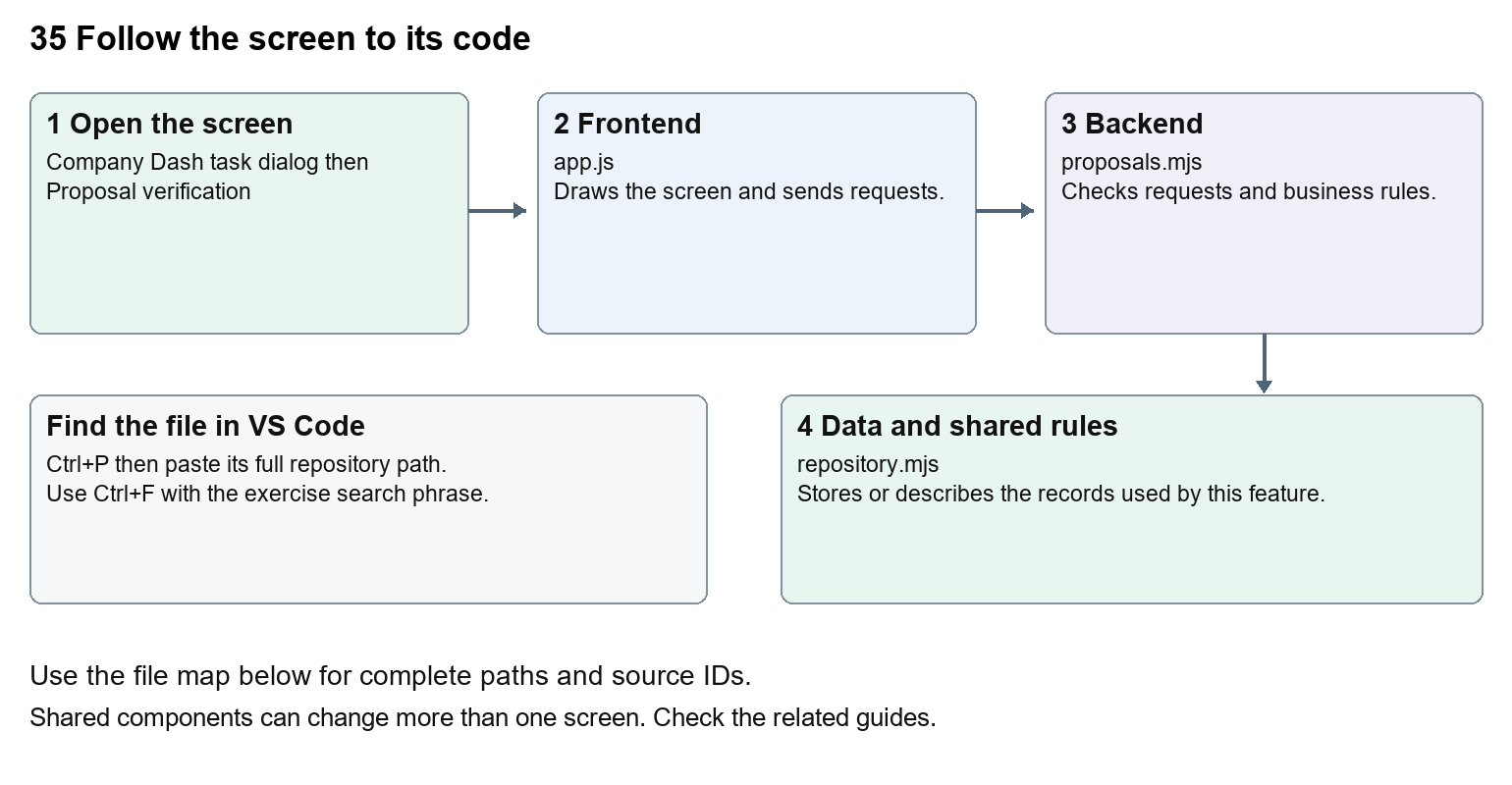
The diagram shows the file roles. The full paths below are what you paste into Ctrl+P.

Find the files in VS Code
Role | File and source ID | What it does
Screen | S0696 app.js | Main UI or route for this topic
Server | S0707 proposals.mjs | Endpoints or server rules
Data | S0708 repository.mjs | Data shape or persistence structure

Screen S0696
public/app.js
Server S0707
server/proposals.mjs
Data S0708
server/repository.mjs
Use the HTML source buttons for full files. Word shows labelled extracts; individual Markdown guides contain complete primary files.

Follow the request and the records
1. Read the task report and proposed patch before starting relevant proposal QA.
2. Review integration requests POST /api/integration/preview with a task id.
3. The backend checks the latest proposal, accepted handoffs, exact-source QA and unchanged original baseline.
4. A separate review copy and cumulative patch are returned for operator inspection.
5. Apply reviewed changes revalidates the review and updates the local Nexora checkout; checkout QA follows.

Read the code with an explanation
public/app.js creates proposal controls and a review dialog. proposals.mjs requires passing evidence for the exact proposal fingerprint and compares the original checkout baseline. A downstream proposal includes earlier accepted developer changes. The review key expires after fifteen minutes and is revalidated on apply. Matching architecture evidence covers only that suite; choose API or browser checks when the change requires them. Applied source remains a local change until it is deliberately committed, pushed and deployed through the appropriate workflow.
Source reference S0696 company-dash/public/app.js
Extract from source line 68. A fragment from a long line is shown without the rest of that line.
0068 function proposalActions(task) {

index.html supplies markup and app.js renders browser views. Follow api() to the server route handler.
Source reference S0707 company-dash/server/proposals.mjs
Extract from source line 14. A fragment from a long line is shown without the rest of that line.
0014 export async function proposalReview(store, config, taskId) {

The browser api() helper sends a method and local request token. app.mjs checks the route and calls the relevant service. Follow that call to understand SQL writes, process execution and filesystem changes.
Source reference S0708 company-dash/server/repository.mjs
Selected opening lines with their original numbers. The complete file is in the HTML source library.
0001 import fs from 'node:fs/promises';
0002 import path from 'node:path';
0003 import { execFile } from 'node:child_process';
0004 import { promisify } from 'node:util';
0005 import { createHash } from 'node:crypto';
0006 const exec = promisify(execFile);

store.mjs defines SQLite history tables. catalog.mjs and config.mjs define configuration; repository.mjs records fingerprints. Trace each key into its service before assuming it is a stored table.

Make or trace your first change
1. Press Ctrl+P and open server/proposals.mjs.
2. Press Ctrl+F and search for Run proposal QA on this exact source before integration.. In this snapshot it appears at line 26.
3. Read-only exercise: find the exact-source QA requirement, then the original-checkout comparison and expiry check. Explain why a stale proposal must be refreshed rather than forced into the checkout.
4. Record the file, request path and server handler you found. This exercise is read-only; no stored records need to change.
Extract from source line 26. A fragment from a long line is shown without the rest of that line.
0026 if (!evidence.length) throw new Error('Run proposal QA on this exact source before integration.');

These exercises have not been applied to the application. Their search phrases are verified against the captured source. Line numbers can move; the phrase and file path are your main navigation aids.

Check a change and diagnose problems
Confirm the original screen still loads, the changed words appear in the intended place, and another screen using the same component still behaves correctly. If an action fails, inspect the browser Network response, the relevant helper and server validation message. Use the common error table at the beginning of the manual. Reload on a version conflict instead of removing the version check.
A syntax error after a text edit usually means a quote, brace or closing tag changed. Compare your diff with the original. An unchanged browser result can mean the wrong port, a saved published configuration overriding a default, or a running API that has not reloaded.

Understand the current limits
Accepting a handoff does not integrate code. Apply is an explicit state-changing operator action; never bypass the baseline or evidence checks. This documentation task does not review or apply any live proposal.

Continue learning
Related guides 30 Nexora backend database and maintenance, 32 Company Dash repository and source viewer, 33 Company Dash tasks agents and handoffs, 34 Company Dash QA and verification.

